HEART IOS 2 Field Test Project Enrolment Form

Personal data:
Please fill out with CAPITAL LETTERS

First Name: | Last Name:
Date of birth (dd/mm/yyyy): | Gender
Address (house number, street, town, postcode, country):
Telephone: Include Country code
Email:
Health Card Number: Optional

Course details: Heart Project IOS 2 Resilience and Burn Out Prevention Field Test: Alive Arts
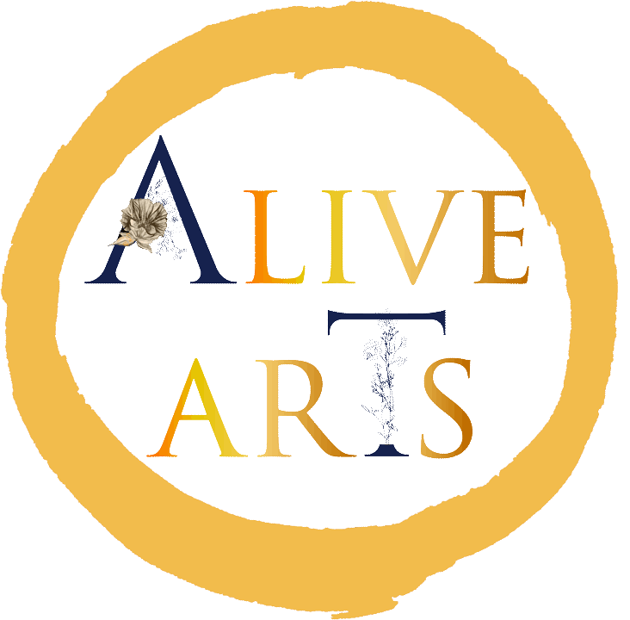



Please give a brief background of your experience in Arts, Movement, Health and Outdoor Experiential Education

…………………………………………………………………..…………………………………………………………………..…………………………

……………………………..…………………………………………………………………..…………………………………………………………………

..……………………………………………………………………………………………………………………………………………………………..

Medical and Health
Answer with YES or NO for the questions:

Allergies (medication, food, others)? |  | Blood pressure problems?
Medical treatment? |  | Problems with back, shoulder, knee, ankle or other joints?
Will you bring any medicine with you? |  | Other (diabetes, asthma, epilepsy, migraine, etc.)
Have you been hospitalized in the past two years? |  | Other (diabetes, asthma, epilepsy, migraine, etc.)
Cardiac problems? |  | In case of women: pregnant?

The unanswered questions are considered as negative answer. If you answered with YES any of the above items, please give details (symptoms, medication, special requests) …………………………………………………………………..…………………………………………………………………..…………………………………………………………………..…………………………………………………………………..…………………………………………………………………..…………………………………………………………………..

Date and Participants printed signature: ………………………………………………………...……………………..

Heart Project Liability Waiver Agreement

Please read, understand and agree to the following disclaimer/waiver before participating in an online Heart IOS2 field test with Alive Arts or your trainer.
If you have any questions please email admin@alivearts.org or the trainer who has contacted you.

By signing up for the Online Heart Workshop Provided by ‘Alive Arts’ and your Trainer you hereby agree to the following:

I am participating in the live streaming of the Heart IOS 2 event - an Erasmus + Funded field test during which I will receive instruction through Zoom.

I understand that is my responsibility to ensure, to the best of my ability, that my internet connection is working before and during the live online class. If the Zoom platform breaks down the facilitator will connect with me via mobile or email with regard to an alternative connection.

I understand that it is my responsibility to consult with my doctor prior to any online classes regarding any health conditions and existing or pre-existing injuries.

I confirm that I am physically fit, mentally stable and have no medical condition that would prevent my full participation in the live online class.

I agree to assume full responsibility for any risks, injuries or damages, known and unknown, which I might incur as a result of participating in the programme.
The Leader Organisation will not be held responsible for any accidents or other incidents that arise from participating in the event. I knowingly, voluntarily and expressly waiver any claim I may sustain as a result of participating in the online programme offered.

I assume full responsibility for my own safety and wellbeing. In addition, I agree that I will remain vigilant and responsible in relation to others and the environment.

In preparation for the online class via Zoom, please ensure that you are in a private setting. If in a public setting please use headphones. Ensure that you have space to move around in safely. Wear appropriate footwear and comfortable clothing that supports you to move in and engage in an Arts and Experiential educational practice. Please ensure that you keep hydrated so have water on hand. Your facilitator will send details of what you need for the workshop.

Some activities may involve creative and movement explorations that involve some physical exertion. You are engaging in this activity at your own risk. It is up to you to perform these activities in an open area free from obstacles. Please go at your own pace.

If at any point during the workshop you begin to feel faint, dizzy or physical discomfort, you should stop immediately, let your facilitator know and consult with a doctor.

The information provided by you on this form helps us design a programme to fit your needs, your physical abilities and to offer help for any physical limitations you may have. All of this information is strictly confidential.

Participants must be 18 years of age or over. Smoking and alcohol use is expressly forbidden during the programme. Failure to comply with this ruling will result in the participant being withdrawn from the course.

I AGREE to allow the thematic leader organisation, Alive Arts and Élményakadémia, to use all images, movies and testimonials that are taken during the workshop for support of the Erasmus + funded project and marketing or other purposes needed in securing future funding.

I declare that I have read and understood the above and that I agree with what is written on this enrolment form.

Date and Signature - Print: …………………….…………………………………………
(input from a keyboard will be accepted)
The contact person in case of emergency: (Please provide full international phone numbers)
Name: …………………………………………………………………………….
Relationship:……………………………………………………………………
Emergency phone number:……………………………………………………………

When you have completed the Enrolment and Waiver parts of the form, email it as an attachment to:
admin@alivearts.org with the Subject as ‘Heart IOS 2 Workshop Application’
Apart from the details you are required to complete, no wording on this form must be altered.

Your details will be kept safe and secure, only used by those who work for the HEART project and for the Élményakademia and will not be shared with anyone else. We use this information to contact you about the above-mentioned programme. Electronic data and databases are stored on secure computer systems and we control who has access to information.

